Trader Performance vs. Bitcoin Market Sentiment
An Exploratory Analysis of Hyperliquid Trading Behavior Across Fear & Greed Regimes

1. Executive Summary
This analysis merges 211,224 individual trade records from 32 Hyperliquid trader accounts with the Bitcoin Fear & Greed Index to examine whether market-wide sentiment is associated with differences in trader behavior and profitability. After matching every trade to its sentiment classification by date, 100% of trades (211,218) were successfully matched.
The headline finding: trader behavior changes substantially with sentiment (positioning flips from long-biased in Fear to short-biased in Greed), while raw profitability differences between regimes are smaller and statistically fragile. This distinction — sentiment shapes what traders do far more clearly than it shapes how much they make — is the central insight of this report.

2. Data & Methodology

2.1 Datasets
- Bitcoin Fear & Greed Index: 2,645 daily readings (Feb 2018 – May 2025) with a 0–100 sentiment score and a 5-class label (Extreme Fear, Fear, Neutral, Greed, Extreme Greed).
- Hyperliquid Historical Trades: 211,224 trade-level records across 32 accounts and 246 traded assets, including execution price, size, side, direction (open/close, long/short), closed PnL, and fees.

2.2 Approach
- Each trade's timestamp was normalized to a calendar date and joined to that day's sentiment classification.
- A simplified 3-class sentiment (Fear / Neutral / Greed) was derived by merging Extreme Fear→Fear and Extreme Greed→Greed, used for the primary comparisons; the full 5-class breakdown is retained for granularity.
- Metrics computed per sentiment regime: total and average PnL, win rate, trade/position sizing, long vs. short positioning, trading volume, and per-account profitability.
- Statistical significance was tested with a Mann-Whitney U test (robust to the heavy skew/zero-inflation in per-trade PnL) and a Welch's t-test, plus Pearson correlations between the daily sentiment score and daily aggregates.

3. Key Findings

3.1 Overall performance by sentiment regime
Sentiment | Trades | Total PnL ($) | Avg PnL/Trade | Win Rate | Avg Trade Size | Volume ($M)
Fear | 83,237 | 4,096,266 | $49.21 | 40.8% | $7,182 | 597.8
Neutral | 37,686 | 1,292,921 | $34.31 | 39.7% | $4,783 | 180.2
Greed | 90,295 | 4,865,301 | $53.88 | 42.0% | $4,574 | 413.0

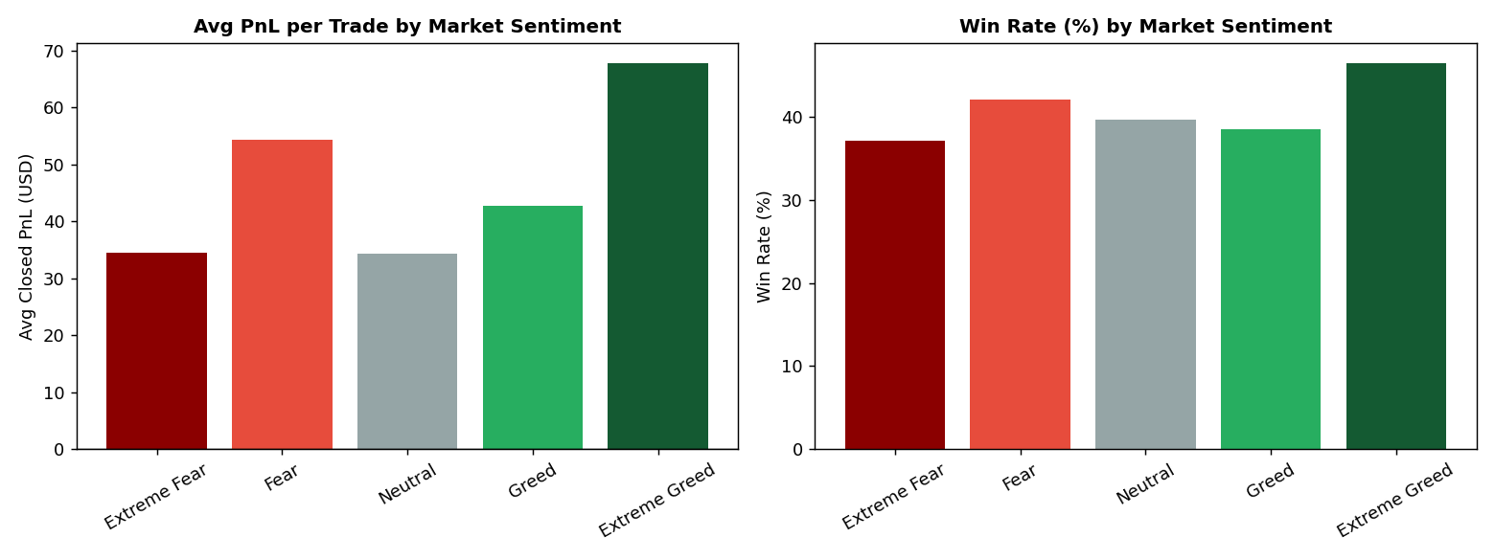
Figure 1 — Average PnL per trade and win rate are both slightly higher in Greed than Fear, and lowest in Neutral (5-class breakdown).
Average PnL per trade and win rate are marginally higher during Greed than Fear. However, the effect size is small: win rates only range from 37–46% across all five sentiment classes, and a Welch's t-test on Fear-vs-Greed PnL is not significant (p = 0.32). A Mann-Whitney U test, which is more appropriate given the heavily skewed, zero-inflated PnL distribution, does find a significant difference in distribution shape (p < 0.001) — meaning the two regimes' PnL distributions differ, even though mean PnL does not differ dramatically.

3.2 Positioning flips sharply with sentiment
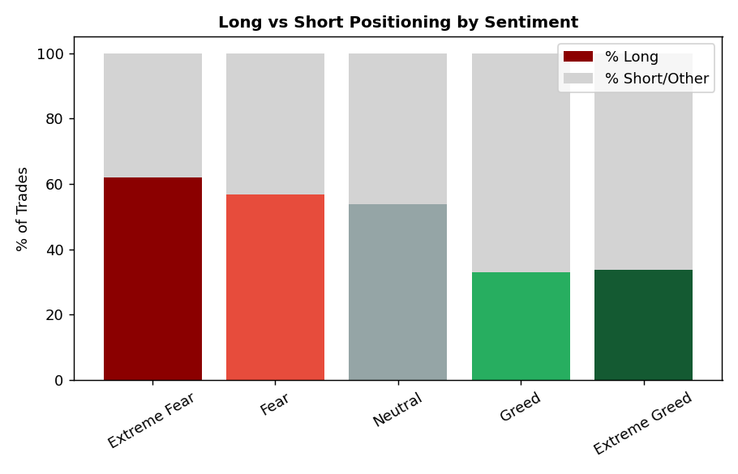
Figure 2 — Share of trades opened Long vs. Short/Other, by sentiment.
This is the strongest pattern in the dataset. During Fear and Extreme Fear, 57–62% of trades are long-biased. During Greed and Extreme Greed, that flips to only 33–34% long — meaning roughly two-thirds of trades are short-biased. Traders in this dataset behave in a contrarian-leaning way: they lean long when the market is fearful (potentially buying the dip) and lean short when the market is greedy (potentially fading euphoria or taking profit into strength).

3.3 Activity and volume rise as fear increases
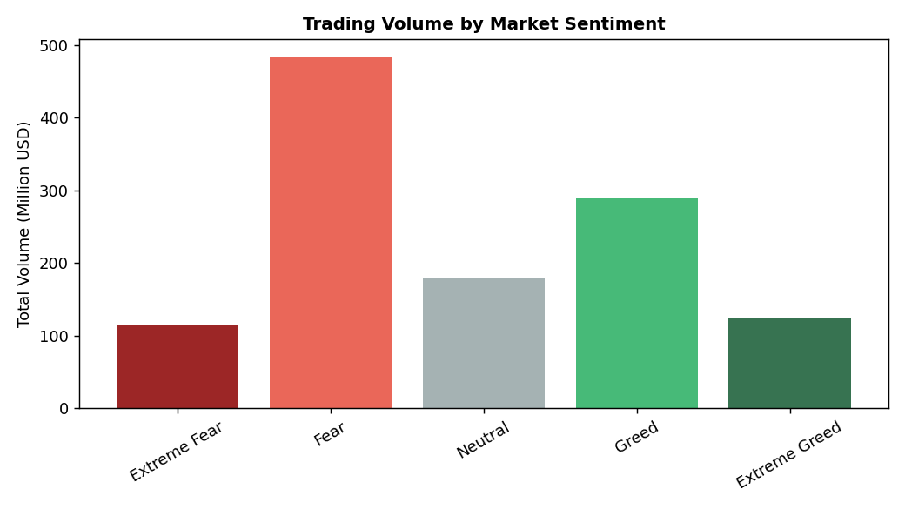
Figure 3 — Total trading volume by sentiment class; Fear sees the highest volume.
Trading volume and trade count are both negatively correlated with the sentiment score (volume: r = -0.264, trade count: r = -0.245) — meaning more trades and higher dollar volume occur as the market becomes more fearful, not less. 'Fear' alone accounts for $598M of volume, the largest of any single regime, even more than 'Greed' ($413M). This suggests fear periods drive more urgent or opportunistic trading activity.

3.4 Sentiment vs. daily PnL over time
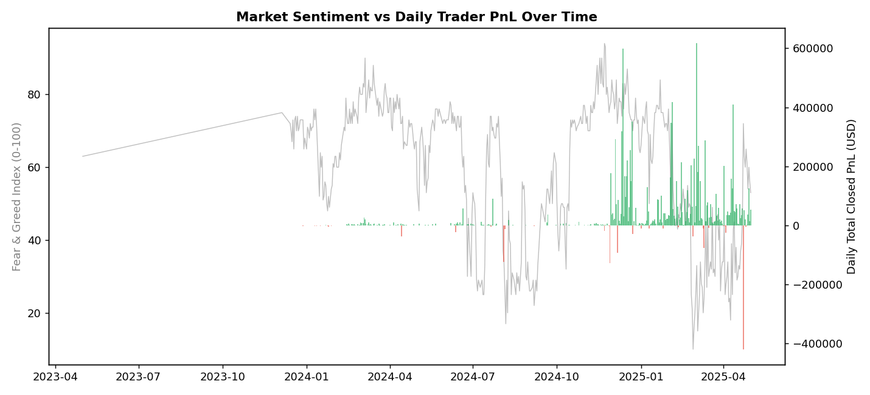
Figure 4 — Daily Fear & Greed score (line) vs. daily total closed PnL (bars, green=profit/red=loss).
Visually, large positive and negative PnL days do not cluster tightly around any one part of the sentiment scale — profitable and unprofitable days occur throughout Fear and Greed periods alike. The correlation between the raw sentiment score and daily PnL is weak (r = -0.083), reinforcing that sentiment alone is a poor direct predictor of daily profitability for this trader cohort.

3.5 Is this a broad pattern, or a few accounts driving it?
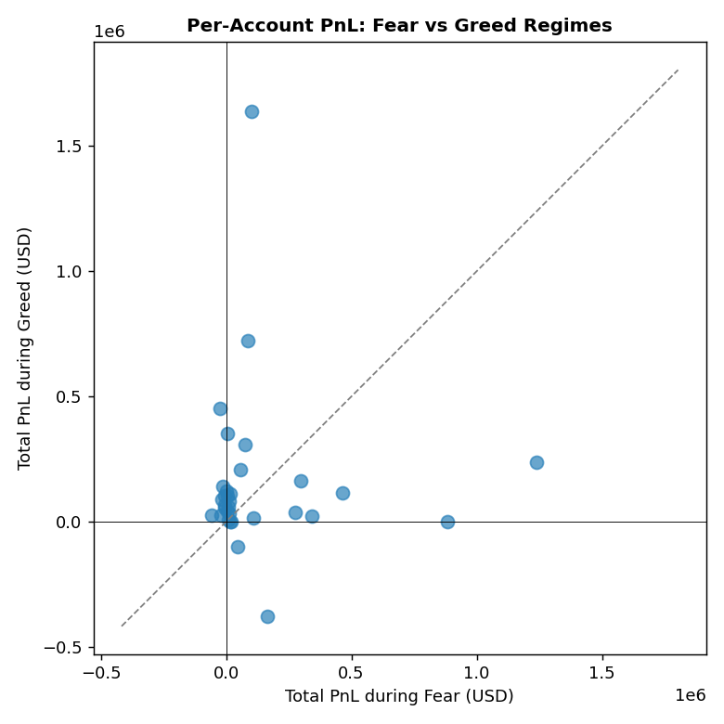
Figure 5 — Each point is one account's total PnL during Fear (x-axis) vs. Greed (y-axis). Points above the diagonal made more in Greed; points to the right of zero were profitable in Fear.
24 of 32 accounts (75%) were net profitable during Fear, and 29 of 32 (91%) were net profitable during Greed — so profitability in Greed is both more common and, on average, larger (mean account PnL: $152,041 in Greed vs. $128,008 in Fear). This is a broad-based pattern across most accounts rather than a handful of whales skewing the average, though a few large accounts do contribute disproportionately to total PnL in both regimes.

3.6 Asset preferences shift too
BTC dominates traded volume in both regimes ($338M in Fear, $208M in Greed), but the next-most-traded assets differ: SOL and HYPE see relatively more volume during Fear, while ETH sees more relative volume during Greed — a secondary hint that traders rotate their asset focus, not just their direction, with sentiment.

4. Interpretation: What's Really Going On
- Sentiment is a behavioral signal, not a profitability signal. It strongly predicts what traders do (long/short bias, how much they trade) but only weakly predicts whether they make money.
- The trader cohort in this dataset skews contrarian: buying into fear, and increasing short exposure into greed — the opposite of naive sentiment-following ("buy when everyone's greedy").
- Fear periods are the busiest, not the quietest. Volume and trade count rise as fear deepens, suggesting these traders treat fear spikes as opportunities rather than reasons to sit out.
- Profitability is broad-based, not whale-dependent: most accounts (75-91%) are net profitable in both regimes, with a modestly better track record during Greed.

5. Actionable Insights for a Trading Strategy
- Use sentiment as a position-sizing and bias filter, not a standalone signal: the data supports leaning long-biased in Fear and reducing/hedging long exposure (or adding shorts) in Greed, consistent with what this cohort already does profitably on average.
- Expect higher activity and opportunity during Fear spikes — allocate more monitoring/liquidity bandwidth for these periods rather than treating them as "risk-off, sit on hands" windows.
- Don't rely on sentiment alone to time individual trades: the weak correlation with daily PnL (r ≈ -0.08) means sentiment should be combined with price action, volume, or account-specific edge rather than used in isolation.
- Favor BTC, ETH, and SOL as the highest-liquidity venues across both regimes; consider that ETH's relative share rises in Greed and could warrant a slightly larger allocation there during greedy periods.
- Given 91% of accounts were profitable during Greed vs. 75% during Fear, risk controls (stop-losses, reduced size) may be more valuable during Fear regimes, where the spread of outcomes (both up and down) is wider.

6. Limitations
- The dataset covers only 32 accounts, which limits how confidently these patterns generalize to the broader Hyperliquid trader population.
- No explicit leverage column was present in this trade dataset, despite leverage being commonly available in Hyperliquid data; long/short positioning was instead inferred from the Direction field (Open/Close Long/Short), so leverage-specific conclusions (e.g., whether traders take on more risk in Fear vs. Greed) could not be tested directly here and are flagged as a direction for future analysis if a leverage field becomes available.
- Sentiment is measured once per day while trades occur intraday, so within-day sentiment shifts are not captured.
- Closed PnL reflects realized trades only; unrealized/open-position performance at the time of each sentiment reading is not captured.

7. Conclusion
Market sentiment, as measured by the Fear & Greed Index, is clearly associated with how this group of Hyperliquid traders positions itself — flipping from long-leaning in Fear to short-leaning in Greed — and with how much they trade, with Fear periods driving the highest volume. However, sentiment is only weakly linked to actual profitability, which appears driven more by execution and asset selection than by the sentiment regime itself. The most defensible strategic takeaway is to treat sentiment as a behavioral and risk-context indicator that shapes exposure and activity levels, not as a direct profit signal.

